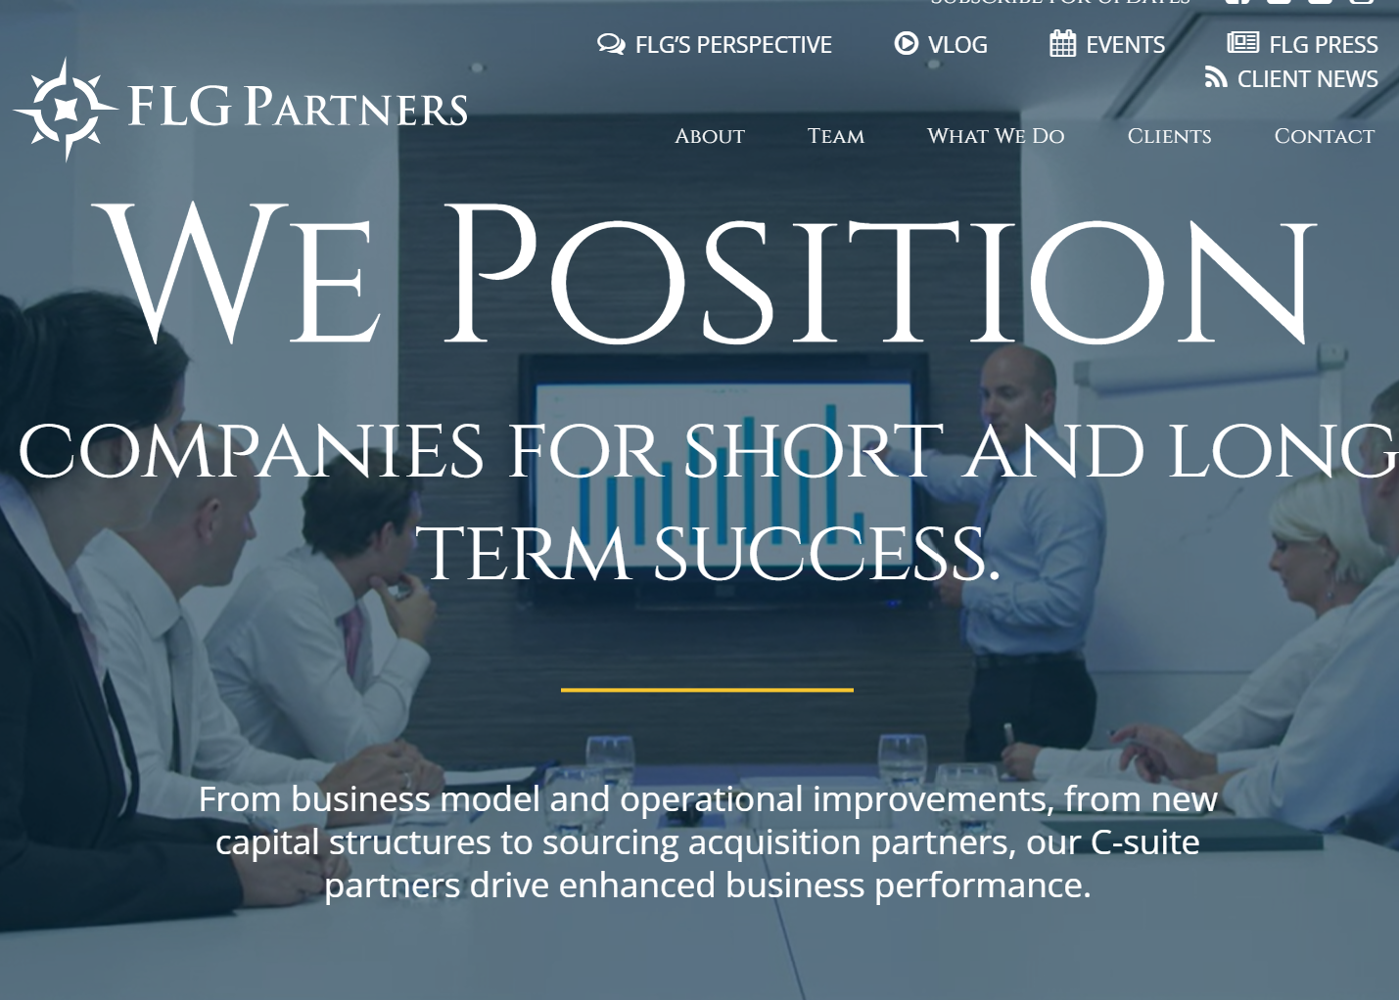


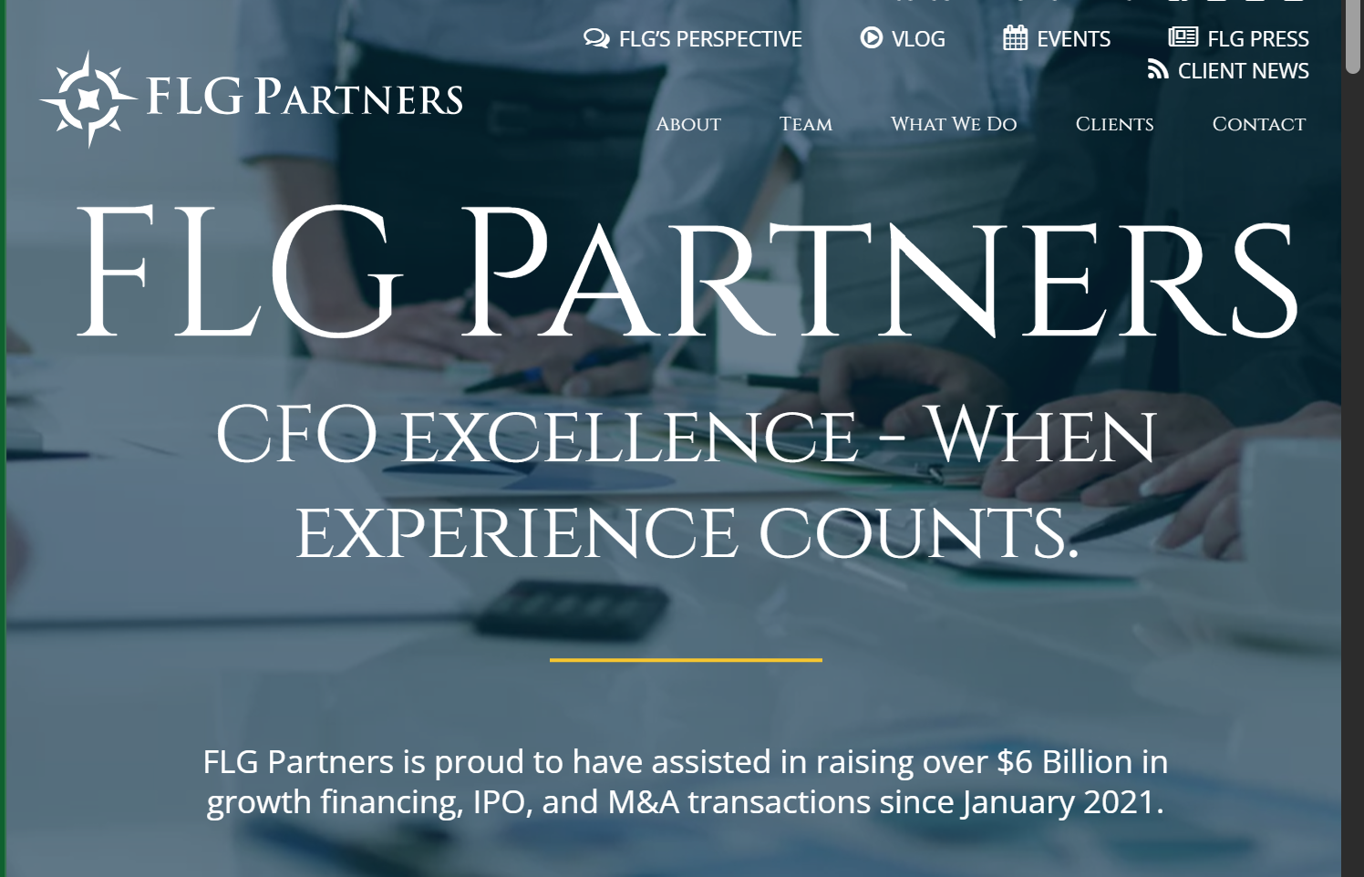
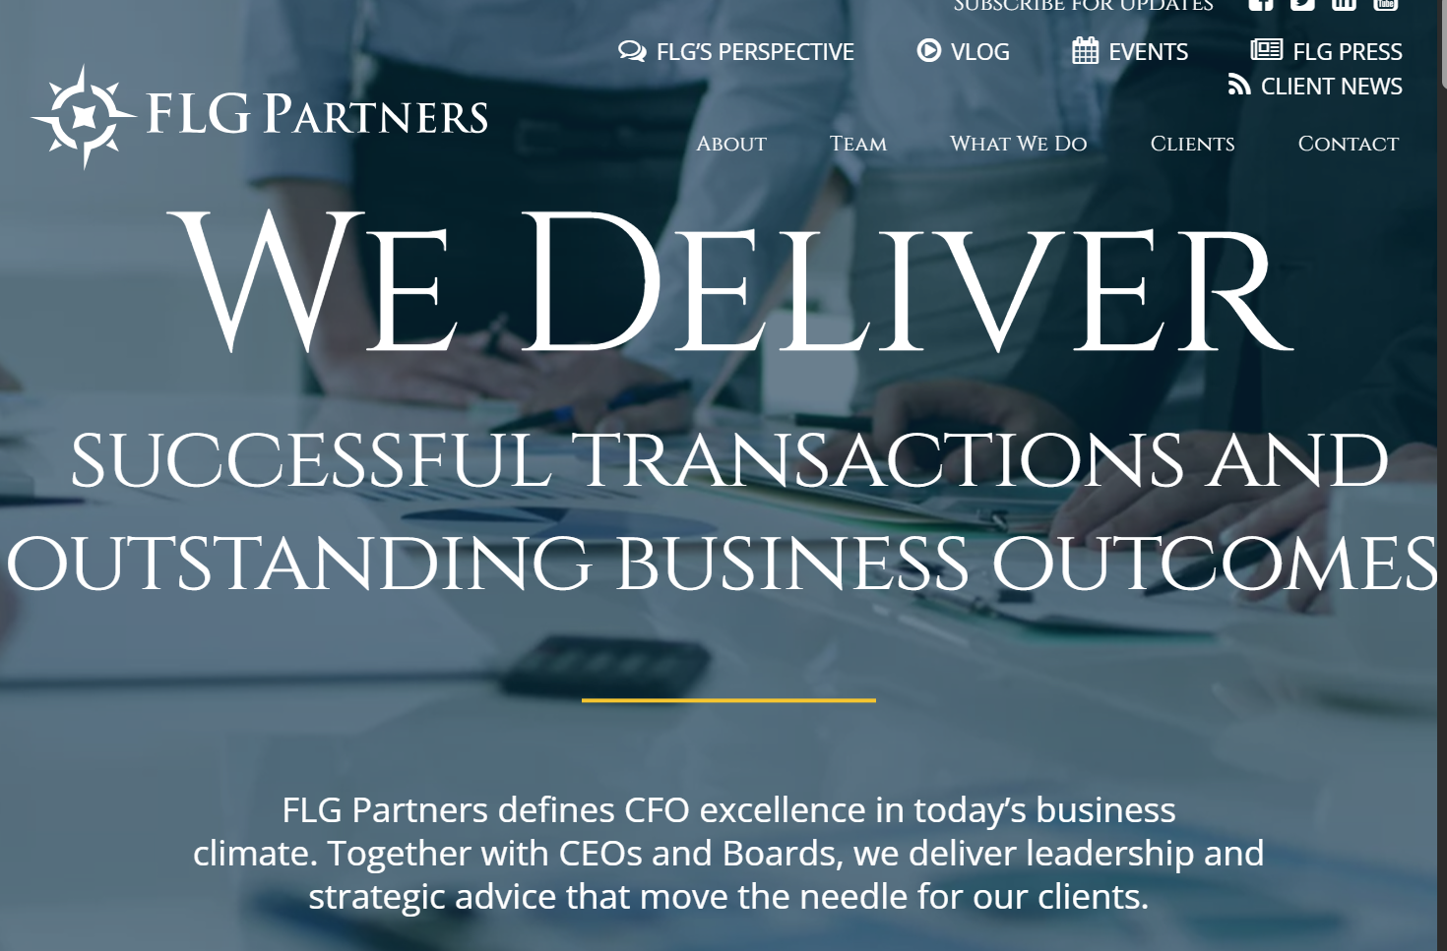
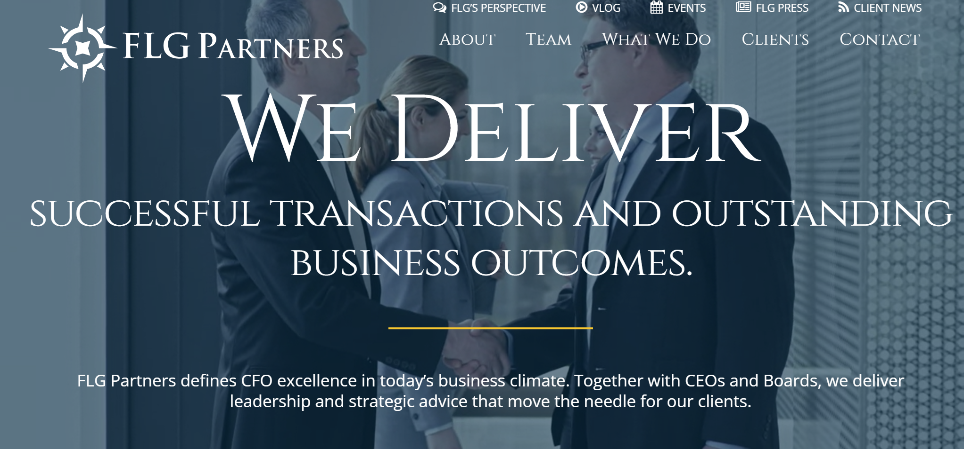



Landing page

CFO EXCELLENCE – When EXPERIENCE COUNTS.
FLG Partners is proud to have assisted in raising over $6 Billion in growth financing, IPO, and M&A transactions since January 2021.

image 1:
WE POWER GROWTH, CASH FLOW AND PROFITABILITY FOR COMPANIES.
From debt and equity financings to M&A and IPO readiness, at FLG Partners we increase the value of your enterprise.
Image 2:
WE DELIVER
SUCCESSFUL TRANSACTIONS AND OUTSTANDING BUSINESS OUTCOMES.
FLG Partners defines CFO excellence in today’s business climate. Together with CEOs and Boards, we deliver leadership and strategic advice that move the needle for our clients.
Image 3:
WE POSITION COMPANIES FOR SHORT AND LONG TERM SUCCESS.
From business model and operational improvements, from new capital structures to sourcing acquisition partners, our C-suite partners drive enhanced business performance.
Image 4:
We Leverage
OUR EXPERIENCE, EXPERTISE, NETWORKS AND RELATIONSHIPS.
For startups to high‑growth, emerging companies, FLG’s strong relationships with bankers & funders are a competitive advantage – for you.

About
Founded in 2004, FLG Partners is a leader in CFO solutions and CEO and Board advisory services in Silicon Valley and nationwide. FLG delivers financial and operational leadership to companies ranging from startups to multi-billion-dollar public and private enterprises across technology, AI, life sciences, consumer products, and manufacturing.
FLG Partners provides interim and permanent CFO and C-suite leadership, CFO consulting, board directorships, and board advisory and performance consulting. With more than 950 years of combined CFO experience, FLG partners bring deep expertise, independence, and objective leadership grounded in proven best practices.
FLG combines this experience with a modern, technology-enabled approach. FLG brings AI-enabled tools into client operations to drive better analysis, operational efficiency, and decision-making, with clear governance and experienced human oversight. All partners are deeply committed to continual investment in AI training to ensure responsible, informed, and practical use of AI in service of clients.
Throughout their careers, FLG partners have completed approximately 350 M&A transactions, 200+ IPOs and secondary offerings, more than 100 divestitures, and have raised $19 billion in equity and $12 billion in debt. FLG partners advise clients across business planning and execution, fundraising and financing, SEC reporting, tax and regulatory compliance, mergers and acquisitions, and complex turnarounds and restructurings.
FLG Partners offers our clients bespoke solutions, from part-time, interim and, on occasion, W2 full-time leaders to board advisory support, project management, C-suite mentoring and leadership skillbuilding.<="" span="" style="box-sizing: border-box; -webkit-tap-highlight-color: rgba(0, 0, 0, 0); background: transparent; border: 0px; margin: 0px; padding: 0px; vertical-align: baseline;">

Why FLG?
We’re a different solution for CEOs and boards seeking
more experienced, C-suite level talent in a CFO role. Here’s why.
The role of the CFO today is more critical – and more complex – than ever.
A faster pace is the new norm. With the rapid evolution of technological innovation, volatile financial markets, evolving business models, and increasing pressure to grow revenues and find new customers, today’s Chief Financial Officers must be able to quickly translate data into meaningful and actionable information for competitive advantage. Agile CFOs who can learn quickly, adapt to changing business conditions and apply fresh, new approaches to problem solving are essential.
You need an experienced financial leader on your team with the right set of strategic mindset, management expertise, technical and operational skills and business know-how to tackle today’s and tomorrow’s challenges. CEOs, Boards and management teams must have seasoned CFO talent to lead new growth initiatives, fund raise with different types of investors and vehicles, scale a business effectively, proactively manage cash and margins and execute M&A, IPO and financing transactions successfully.
Whether interim, part time or full time, you need the right CFO on your team.

FLG Partners leverages our collective experience and networks to provide our clients with the highest quality CFO advisory expertise available on the market.
We do this in 5 ways:

We’re more experienced and C-suite only.
FLG’s partners are highly experienced executives with deep credibility as CFOs, extensive banking and investor networks, impressive transactional and domain sector expertise and strong skills from complex accounting to strategic problem solving. We are known for our strong track record raising capital for our clients. Our CFOs have successfully led finance functions in public and private companies undergoing significant transition, from rapid growth to restructurings, IPOs and liquidity events. Our deep domain expertise across multiple industry sectors including healthcare, technology, consumer products (among others) give the FLG CFO the competitive edge. FLG partners are also noted for our strong leadership skills. This results in a well-rounded, seasoned executive who has the depth of experience to solve our clients’ toughest business issues.

We put a premium on being innovative and agile.
FLG Partners thrives at the intersection of disruption, innovation and change. When you grow up in Silicon Valley, you see and do – a lot. We understand risk management, incentive rewards and regulation. We also understand data analytics, how to weigh investments in IT, SaaS, and MarTech and how to navigate software and life science product roadmaps. Our partners have managed the full continuum of business lifestyles and lifecycles, from startups bootstrapping their operations and watching their cash burn to Series C emerging companies preparing to go public to private equity-funded exits. We’ve worked with and for some of the premier venture firms.
We are intensely collaborative and 100% client focused.
At FLG, our culture is one of deep commitment to our clients and mutual respect, collaboration and trust within our partnership. Our clients are our number one source of new business and we have longstanding relationships with many of them. We are highly collaborative – with our clients, with each other and with our professional networks – to deliver the best possible solutions to our clients. We are proud to have established strong referral partnerships with VCs, investment banks, PE firms, top law firms, banks, accounting and recruiting firms, locally and nationally.
We’re CEO-centric and board accountable.
A FLG partner is a CEO’s right hand as well as the board’s check and balance on corporate accountability. Our clients tell us that we understand the daily realities of our CEOs and boards better than anyone. Great CFOs are strategists as well as trusted business partners for their CEOs. We’re often asked by CEOs to help recruit and vet subsequent CFO hires. We’re always happy to help. The best CFOs are objective sounding boards, architects of growth, and financial artists for their CEOs. They are valued operating executives on the management team as well as strong, independent voices for robust corporate governance. They must be able to navigate through disruptive organizational inflexion points while leveraging these critical relationships.
Our litmus test for a FLG CFO is this: “As a CEO, would you be comfortable delegating to your CFO a binding conversation or critical negotiation on behalf of your company with a third party such as a regulator, partner, or investor?”
If your CFO is a FLG partner, the answer is “YES”.

Contact Us Today To Learn More About How FLG Can Become Your CFO Solution
Learn More

What We Do: Startups
FLG works with startups, from seed stage to emerging, often referred to us by venture capital firms, private equity firms, private investors, law firms and bankers.
Startups and emerging companies need to raise capital, hire talent and build infrastructure. These high growth players also need to establish brand traction with their customers and sales channels, gain investor confidence, create convincing proof of concept, stabilize their cash burn, establish planning processes, and wrap it all around a compelling brand story. They must grow organically while juggling extreme operational and financial pressures, a young and changing organization, shifting business models, lack of policies and infrastructure while they rein in inefficient spending habits.
FLG Partners assists startup and emerging company CEOs and their boards set clear and measurable objectives, build financial controls and standards, add systems and reporting mechanisms, fundraise for growth (angel, seed, A/B rounds), and create organizational structure. Our CFOs establish disciplines in new companies from human resources to cash management, from forecasting to demand planning. They identify effective strategies for scaling business and help build company culture.

What We Do: High Growth
FLG is often brought in to work with CEOs and boards at high growth companies aggressively raising capital & growing their customer portfolios.
￼
FLG Partners provides interim CFO consultants to many high growth and hyper growth emerging companies. High growth organizations are under significant stress as they simultaneously focus on venture and investor fundraising, scaling their business via sales and business development, expanding their strategic partnerships, and improving the efficiency of their business models. They must juggle cash management and EBITDA with an overriding drive towards profitability. As they prioritize raising C, D, E+ rounds and attracting the right investors, they need to build their capitalization structures and decide whether or not to take on more debt. They need to strategically build a strong board of directors and recruit and retain key players on their management teams to add skills and experience as they scale. They must build enterprise systems and more professionalized business processes and protect their expanding brand and book of business with effective risk and liability management.

What We Do: Mature Operating Lift
Many operating companies, even those that have matured as organizations and brands, can find themselves lost in a thicket of financial challenges.
CEOs and boards must also sometimes accept the realization that their existing CFO may not have the sufficient depth of experience and/or skillset to take the company to the next level of development so that they can capitalize on market opportunity in the timeframe they need to.
Confronting and resolving strategic, regulatory and/or operational threats while meeting public market expectations (or even private investor demands) can be daunting. A CFO, in these “mature company moments”, must be able to rapidly prioritize and address urgent organizational challenges while exerting strong leadership to “own” financial problems and establish effective operational and financial controls to curtail these in the future. They must be comfortable presenting cases to the board while being inspiring and “leader-like” with employees, showing them why and how to modify existing operating business processes to reach new objectives. And they must build infrastructure in their own finance organizations to enhance the sophistication with which their teams add capacity and capability to manage change, evaluate system development and improve cross-functional collaboration.
FLG’s expertise in operation finance is derived from our partners’ extensive depth addressing so many distinctly unique operating company situations from a financial perspective. Our partners are able to quickly assess the financial landscape and business requirements at our clients, prioritize effective responses and then rapidly deploy the right financial and operational solutions to solve operational issues. From installing expense control and strategies for preserving working capital to obtaining liquidity financing when needed, from restructuring organizations and staff assignments therein to evaluating the projected ROI from investments, at FLG, we’ve got you covered.

What We Do: Mature Operating Lift
Many operating companies, even those that have matured as organizations and brands, can find themselves lost in a thicket of financial challenges.
CEOs and boards must also sometimes accept the realization that their existing CFO may not have the sufficient depth of experience and/or skillset to take the company to the next level of development so that they can capitalize on market opportunity in the timeframe they need to.
Confronting and resolving strategic, regulatory and/or operational threats while meeting public market expectations (or even private investor demands) can be daunting. A CFO, in these “mature company moments”, must be able to rapidly prioritize and address urgent organizational challenges while exerting strong leadership to “own” financial problems and establish effective operational and financial controls to curtail these in the future. They must be comfortable presenting cases to the board while being inspiring and “leader-like” with employees, showing them why and how to modify existing operating business processes to reach new objectives. And they must build infrastructure in their own finance organizations to enhance the sophistication with which their teams add capacity and capability to manage change, evaluate system development and improve cross-functional collaboration.
FLG’s expertise in operation finance is derived from our partners’ extensive depth addressing so many distinctly unique operating company situations from a financial perspective. Our partners are able to quickly assess the financial landscape and business requirements at our clients, prioritize effective responses and then rapidly deploy the right financial and operational solutions to solve operational issues. From installing expense control and strategies for preserving working capital to obtaining liquidity financing when needed, from restructuring organizations and staff assignments therein to evaluating the projected ROI from investments, at FLG, we’ve got you covered.
What We Do: CFO in Transition
Being a CEO of a company or organization with your CFO in transition is no picnic.
If your Chief Financial Officer has just resigned, been let go or transitioned into another role at the company, you are going to be immediately challenged to say nothing about losing valuable ground ahead. You need a temporary, interim, fractional, part time or full time CFO replacement – NOW.
Imagine being a CEO trying to get through the day with one hand tied behind your back. Now add a blindfold. How do you make decisions? How do you balance priorities? Vet performance communications to key constituencies and partners? Plan for the future? If your goals are to stabilize your business, scale your business or successfully steer the company ship while managing rapid growth, your job is even harder. And of course, you ultimately need a permanent solution for filling your CFO role and a seasoned perspective and solid advice and counsel on that financial front.
You must have someone who can hit the ground running in situations like this. Business savvy professionals who can quickly assess your company’s needs and then self-manage their way towards creating “early wins.” Someone who can easily establish operational and financial controls during periods of explosive growth, and prioritize and address urgent organizational challenges in the short term while building annual & strategic plans for the longer term. You need to find an experienced leader to fight financial and operational fires while you are without a permanent CFO. Someone who can build infrastructure on the finance team, manage systems and business processes, cash management and treasury functions. Then you need that person to recruit, vet and recommend a new CFO – or you need to hire them.
FLG’s partners are experts at just these types of interim and temporary CFO situations. We are the right choice if you find yourself in a situation where you don’t have the right CFO talent – or perhaps any CFO talent – to get the job done. We can rapidly deploy an experienced FLG partner who can work with you to build financial and operational solutions to solve issues as well as strategically plan for future growth and/or exit opportunities. He or she can negotiate expanded lines of credit and help you fundraise, deliver a roadmap for global expansion, deploy new IT and financial systems, organizationally restructure and & coach & mentor your finance team.

What We Do: Board Advisory
FLG Partners offers advisory and consulting services for corporate boards. The partners in FLG’s board practice each have significant experience as sitting members of multiple public and private corporate boards and subcommittees as well as regular and current training, education, and certification in corporate governance best practices through recognized organizations such as the National Association of Corporate Directors and the Directors’ College at the Rock Center for Corporate Governance at the Stanford Law School.

Our services include mediation, education, consulting, and mentoring in a variety of areas, including, but not limited to:

Conducting and leading board off sites
Best practices education and training
Subcommittee restructuring and best practices
On-boarding and training new directors
Off-boarding directors
Director skillset and leadership assessments
Conducting director peer reviews
Succession planning for CEOs and retiring board members
Attend and assess dynamics, practices, and effectiveness of board and committee meetings
Mediating conflicts
Please contact any of the partners below for a further discussion of our capabilities or contact us online to review your board advisory needs.

What We Do: Mentoring
A hallmark of a successful and strategic CFO is the ability to bridge the chasm between a company’s board of directors and its shareholders and the company’s senior management team. That often includes recognizing and nurturing talent within the management team, frequently at the behest of the CEO or board.
FLG Partners frequently assumes a CFO consulting role coaching and mentoring board members and executives across the C-Suite, quite apart from financial management. Our long experience at the senior executive levels of companies allows us to be an effective advocate and mentor for rising executives seeking to position themselves for the next stage of their careers, or to help executives struggling through a challenging time in their present job.
FLG also regularly conducts CEO and CFO bootcamps to assist venture firms with their portfolio company management teams.

FLG’s Partners
Since 2004, FLG has carefully expanded the partnership to include a high-value portfolio of senior-level executives, each with an average of over 25 years of CFO experience in business and financial management, with deep expertise in complex accounting, fundraising and transactional problem solving. FLG’s partners have successfully led finance functions in public and private companies undergoing significant transition, from rapid growth to restructurings, IPOs, M&A and liquidity events.

She is a proven CFO and COO with over 20 years of senior leadership experience guiding and scaling high-growth consumer brands through transformation.. She brings a people-first leadership style, aligning strategy, teams, and operations to drive sustainable growth and profitability.

At FLG, Stephanie has partnered with some of the most innovative consumer brands—including Rothy’s, ThirdLove, goop, Moda Operandi, and Rad Power Bikes—to lead them through pivotal moments of growth and change. Known for her ability to see the big picture while managing the critical details, she blends financial expertise with a leadership approach that empowers teams, strengthens culture, and aligns diverse stakeholders toward shared goals.

has over 30 years of financial and operational experience in public and private companies. Her leadership spans consumer products, entertainment, digital media, technology, and corporate & investment banking sectors. With her astute financial stewardship, integrity, authenticity, and empowering approach to change management, Jennifer earned the trust of C-Suite executives, Boards, senior business leaders, and diverse teams.
Before joining FLG, Jennifer was EVP and CFO of Otter Media, a digital media company acquired by AT&T’s WarnerMedia unit in 2018. Jennifer’s previous roles include SVP & CFO, AT&T Entertainment Group – Technology Operations and Strategy; SVP & Treasurer, DIRECTV, responsible for Corporate Development, Treasury, and FP&A; CFO, Gap Brand North America and Corporate Treasurer of Gap Inc. Earlier in her career, Jennifer was Managing Director at KeyBanc Capital Markets and VP at BNP Paribas, focused on the technology sector.
Jennifer led companies, stakeholders, and cross-functional teams to achieve their targeted goals throughout potentially disruptive events. Demonstrating grace under pressure and delivering excellence in performance, Jennifer led the strategies, solutions, and teams through challenges that included organizational restructurings, changes in executive teams, acquisitions, and divestitures.
At Otter Media, Jennifer led the successful restructuring and integration of Otter Media, consisting of four diverse media companies, into a division within WarnerMedia, shepherding it through the transition from a privately to a publicly held company. During her tenure at DIRECTV, she was selected to head the year-long integration planning for its merger with AT&T. She executed key deliverables, including day-one go-to-market strategies, through collaboration, influence, and engagement.
Since joining FLG Partners in 2020, Jennifer has advised and helped companies succeed, both public and private (family-owned and PE-owned), by assisting them with revenue growth, financial strategy, debt & equity raise, and IPO. Jennifer enjoyed working as an interim CFO and advisor to several lifestyle consumer brands, including goop, Dôen, Keen, and Intermix.
Jennifer is active in a multitude of leadership and Board activities. She is wholeheartedly committed to fostering diversity and inclusion and helping women develop their leadership capabilities. She is a frequent speaker at UCLA Executive Education program “Women in Governance” and is involved with Venture Accelerator of the UCLA Anderson of Management as an advisor and mentor. With regard to Board service, Jennifer is currently an independent Board Director of Fuerst Group and has been serving as a member of Keen Advisory Board since July 2023. Jennifer is also on the board of Operation Gratitude, a non-profit, and has been Chair of its Audit Committee since 2022.

